**Hands on Exercise 1**

In this Hands-On Practice you will code CSS style rules to configure an informational table on a web page. Create a folder named ch9table. Copy the starter.html file from the chapter9 folder in the student files to your ch9table folder. Display thestarter.html file in a browser. The page should look similar to [**Figure 9.10**](https://jigsaw.vitalsource.com/books/9780133971026/epub/OPS/xhtml/fileP7000495062000000000000000002C81.xhtml#P7000495062000000000000000002CDB).

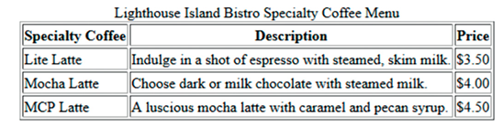

**Figure 9.10 *The table before CSS*.**

Launch a text editor and open the starter.html file from your ch9table folder. Locate the style tags in the head section. You will code embedded CSS in this Hands-On Practice. Position your cursor on the blank line between the style tags.

1. Configure the table element selector to be centered, have a dark blue, 5 pixel border, and have a width of 600px:

table { margin: auto; border: 5px solid #000066; width: 600px; }

Save the file as menu.html and display your page in a browser. Notice that there is a dark blue border surrounding the entire table.

1. Configure the td and th element selectors with a border, padding, and Arial or the default sans-serif font typeface:

td, th { border: 1px solid #000066; padding: 5px; font-family: Arial, sans-serif; }

Save the file and display your page in a browser. Each table cell should now be outlined with a dark blue border and should display text in a sans-serif font.

1. Eliminate the empty space between the borders of the table cells with the **border-spacing** **property**. Add a border-spacing: 0; declaration to the table element selector. Save the file and display your page in a browser.
2. Configure the caption to be displayed with Verdana or the default sans-serif font typeface, bold font weight, font size 1.2em, and 5 pixels of bottom padding:

caption { font-family: Verdana, sans-serif; font-weight: bold; font-size: 1.2em; padding-bottom: 5px; }

1. Let’s experiment and configure background colors for the rows instead of cell borders. Modify the style rule for the td and th element selectors, remove the border declaration, and set border-style to none:

td, th { padding: 5px; font-family: Arial, sans-serif; border-style: none; }

1. Create a new class called altrow that sets a background color:

.altrow { background-color: #eaeaea; }

1. Modify the <tr> tags in the HTML: assign the second and fourth <tr> tags to the altrow class. Save the file. ­Display your page in a browser. The table area should look similar to the one shown in [**Figure 9.11**](https://jigsaw.vitalsource.com/books/9780133971026/epub/OPS/xhtml/fileP7000495062000000000000000002C81.xhtml#P7000495062000000000000000002D0A).

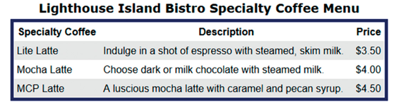

**Figure 9.11 *Rows are configured with alternating background colors.***

Notice how the background color of the alternate rows adds subtle interest to the web page. Compare your work with the sample located in the student files